Level 2: The questions for the Practical Scenario Based Test (Level-2) will be shared with the participants of the certification program on 9th August 2021 (Monday) by 12:00 PM.
The tasks must be completed and submitted back to the Trainer (Manjunatha K) by 12 PM of 11th August 2021 (Wednesday).
Instructions:
- Participants must submit a word document with output of the task along with codebase.
- Create a folder called components in SRC folder and add all your components in it.
- Create file names after task numbers. Ex: Task1.jsx, Task2.jsx, Task3.jsx
- Take the screenshot of each tasks’ results in a word document.
- Include the URL of the page while taking screenshot.
- Export the SRC folder to a zip.
- Send both screenshot document and SRC zip file to trainer.

Task 1:
Create a class-based component that displays current time in HH:MM:SS format where the second time gets updated every second.

Task 2:
Display summary of all COVID19 cases by country in a tabular format for which data is fetched from below API. Add KPIs at the top of the page displaying key numbers like NewConfirmed, TotalConfirmed, NewDeaths, TotalDeaths, NewRecovered, and TotalRecovered.
https://api.covid19api.com/summary
Please find the sample response from the API below and schema of the table to be created.
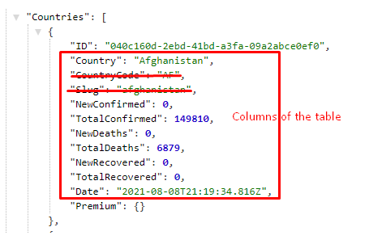
You can make use of React Bootstrap for creating a table or any web component library of your choice.
Find the documentation for the API if you need more details – https://documenter.getpostman.com/view/10808728/SzS8rjbc

Task 3:
Extend the above task and create navigations for the fields – confirmed, recovered, and deaths. Navigate to another view to display another table of below schema.
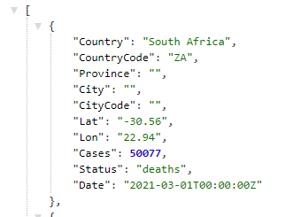
The API endpoints for the navigation is as below.
Confirmed – https://api.covid19api.com/country/south-africa/status/confirmed?from=2021-03-01T00:00:00Z&to=2021-04-01T00:00:00Z
Recovered – https://api.covid19api.com/country/south-africa/status/recovered?from=2021-03-01T00:00:00Z&to=2021-04-01T00:00:00Z
Deaths – https://api.covid19api.com/country/south-africa/status/deaths?from=2021-03-01T00:00:00Z&to=2021-04-01T00:00:00Z

The navigation pattern must be as follows:
/south-africa/confirmed
/south-africa/recovered
/south-africa/deaths

Final Output
